OPTICROP: SMART AGRICULTURAL PRODUCTION OPTIMIZATION ENGINE
PROJECT DOCUMENTATION
Submitted By :-
Kapu Ramya
Team Members ;-
- Nirmal Menati (Team Lead)
- Kapu Ramya
- Mukesh Samudrala
- Mangali Jyothamma
- Akhil Akhil
- Technology ;-

- Artificial Intelligence & Machine Learning

- Organization

- SmartBridge Internship

- Year ;-

- 2026

Table of Contents:-
• Abstract
• Introduction
• Problem Statement
• Objectives
• System Requirements
• Technologies Used
• Dataset Description
• Methodology
• Project Workflow
• Machine Learning Model
• Features
• Results
• Advantages
• Future Enhancements
• Conclusion
• References

- Abstract:-
OptiCrop: Smart Agricultural Production Optimization Engine is an AI and Machine Learning based project that helps farmers choose the most suitable crop based on soil nutrients and environmental conditions. The system analyzes parameters such as Nitrogen (N), Phosphorus (P), Potassium (K), temperature, humidity, pH, and rainfall to predict the best crop for cultivation. The project uses machine learning algorithms to improve prediction accuracy and assist farmers in making data-driven decisions. It aims to increase crop yield, optimize resource utilization, and promote sustainable agriculture.

2. Introduction:-
Agriculture plays a vital role in the economy and food production. Farmers often face challenges in selecting the right crop due to changing environmental conditions and lack of proper guidance. Soil nutrients, weather conditions, and rainfall greatly influence crop productivity. Choosing an unsuitable crop can lead to low yields and financial losses.
The OptiCrop: Smart Agricultural Production Optimization Engine is an Artificial Intelligence and Machine Learning based solution that recommends the most suitable crop by analyzing soil and environmental parameters. The system considers Nitrogen (N), Phosphorus (P), Potassium (K), temperature, humidity, pH, and rainfall to generate accurate crop recommendations. This helps farmers improve productivity, reduce risks, and make informed decisions for sustainable agriculture.
3.Problem Statement:-
Farmers often struggle to identify the most suitable crop because of varying soil quality and climate conditions. Traditional farming methods mainly depend on experience, which may not always provide accurate results. There is a need for an intelligent system that analyzes agricultural data and recommends the best crop for maximum yield and efficient resource utilization.
4. Objectives:-
• To analyze soil and environmental parameters.
• To recommend the most suitable crop using Machine Learning.
• To improve agricultural productivity and crop yield.
• To reduce resource wastage by providing accurate recommendations.
• To support farmers with data-driven decision making.

5. System Requirements:-
Hardware Requirements
- Processor: Intel Core i3 or above
- RAM: Minimum 4 GB
- Storage: Minimum 10 GB free space
- Internet Connection
Software Requirements
- Operating System: Windows / Linux / macOS
- Python 3.x
- Jupyter Notebook / VS Code
- Flask Framework
- MySQL
- Git & GitHub
6. Technologies Used:-
• Programming Language: Python
• Frontend: HTML, CSS, JavaScript
• Backend: Flask
• Database: MySQL
• Machine Learning Library: Scikit-learn
• Data Analysis: Pandas, NumPy
• Visualization: Matplotlib, Seaborn
• Version Control: Git & GitHub
7. Dataset Description:-
The dataset contains agricultural information used for crop recommendation. It includes soil nutrients and environmental parameters such as Nitrogen (N), Phosphorus (P), Potassium (K), temperature, humidity, pH, and rainfall. These features are used to train the machine learning model and predict the most suitable crop
Dataset Attributes:-
• Nitrogen (N)
• Phosphorus (P)
• Potassium (K)
• Temperature
• Humidity
• pH Value
• Rainfall
• Crop Label
8. Methodology:-
The project follows these steps:
- Data Collection
- Data Preprocessing
- Exploratory Data Analysis
- Feature Selection
- Model Training
- Model Evaluation
- Crop Prediction
- Result Generation
- Project Workflow:-
The workflow of the OptiCrop system consists of the following steps:
- User opens the web application.
- User enters agricultural parameters such as Nitrogen (N), Phosphorus (P), Potassium (K), Temperature, Humidity, pH, and Rainfall.
- The system validates the entered data.
- The Machine Learning model processes the input values.
- The trained model predicts the most suitable crop.
- The recommended crop is displayed to the user through the web interface.
10.Machine Learning Modelr:-
The project uses the Random Forest Classifier for crop prediction. This algorithm is chosen because it provides high accuracy, handles multiple input features effectively, and reduces the chances of overfitting. The model was trained using the agricultural dataset and saved using the Pickle library for deployment in the web application.
11.Key Features:-
• AI-Based Crop Recommendation
• User-Friendly Web Interface
• Fast and Accurate Predictions
• Real-Time Crop Recommendation
• Easy Input of Agricultural Parameters
• Machine Learning-Based Decision Support
• Simple and Efficient System
12. Results:-
The developed application successfully predicts the most suitable crop based on the agricultural parameters provided by the user. The Machine Learning model produces accurate recommendations, helping users make better farming decisions. The application is deployed using Streamlit, making it accessible through a web browser.
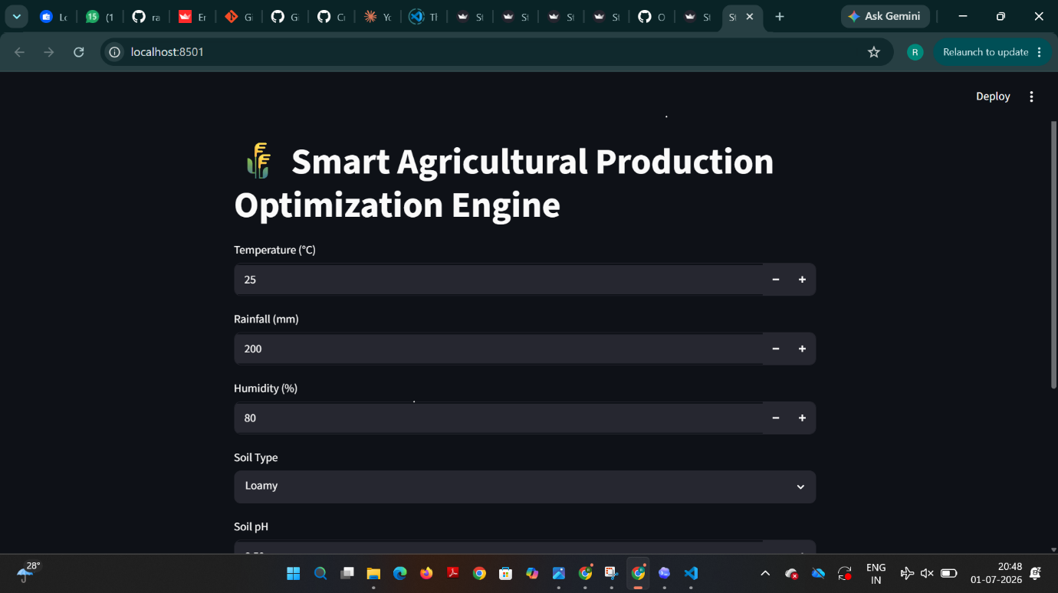
Figure1:Home Page Of Opti crop Application

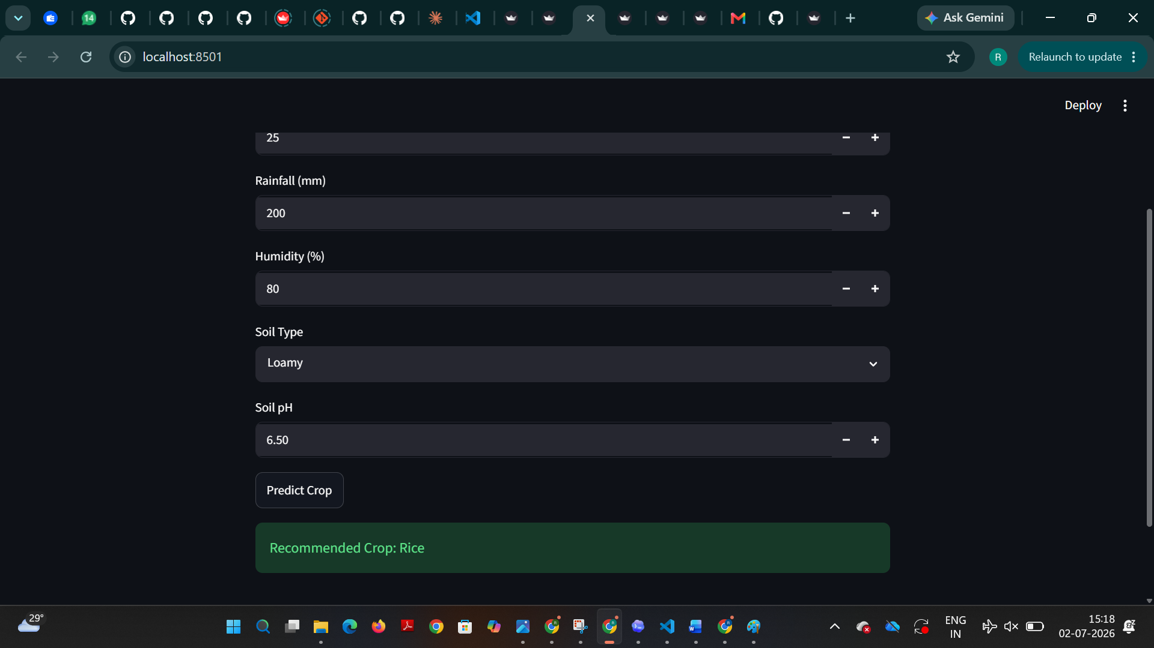
Figure2:crop prediction Result

13. Advantages:-
• Improves crop productivity.
• Assists farmers in making better decisions.
• Saves time and effort.
• Easy to use.
• Supports sustainable agriculture.
• Reduces the risk of selecting unsuitable crops.
14. Future Enhancements:-
- Fertilizer Recommendation System.
- Weather Forecast Integration.
- Crop Disease Detection.
- Crop Yield Prediction.
- Market Price Prediction.
- Mobile Application Development.
- Multi-language Support.
- 15. Conclusion:-
The OptiCrop: Smart Agricultural Production Optimization Engine demonstrates how Artificial Intelligence and Machine Learning can improve agricultural decision-making. By analyzing soil and environmental conditions, the system recommends the most suitable crop for cultivation. This project provides a practical and efficient solution for modern farming and has the potential to be enhanced with additional smart agriculture features in the future.
16. References:-
- Python Official Documentation
- Scikit-learn Documentation
- Pandas Documentation
- NumPy Documentation
- Streamlit Documentation
- Kaggle Crop Recommendation Dataset
- GitHub Documentation

